A

PROJECT REPORT

MARRIAGE BUREAU SYSTEM

Submitted by

**KANISHQ N KHOLE**

&

**RUDULA R NAIK**

Under The Guidance Of

**Prof. Pranali Deshmukh**

In Partial Fulfilment

Of

Bachelor of Business Administration In

Computer Applications

(Semester - VI)

(2019-2020)

ARIHANT COLLEGE OF COMMERCE ARTS & SCIENCE

ACKNOWLEDGEMENT

We wish to record my heartfelt gratitude and sincere thanks to **MRS. PRANALI DESHMUKH** Professor, Department of Computer Applications, ACACS, for her kind support and inspiration given to us till the end of our project.

We thank **MR.SANGRAM KAKDE,** Head & Assoc. Professor, Department Of Computer**, Dr.BHUSHAN PATIL ,**Principal, **ACACS** for their constant support and encouragement given throughout the development of the project.

Last but not the least our sincere thanks to our parents, family members and friends for their continuous support, inspiration and encouragement without which this project would not have been success.

**YOURS FAITHFULLY**

**RUDULA R NAIK**

**KANISHQ N KHOLE**

INDEX

1. INTRODUCTION

* EXISTING SYSTEM
* DRAWBACKS OF EXISTING SYSTEM
* PROPOSED SYSTEM

1. SYSTEM ANALYSIS

* INTRODUCTION TO SYSTEM ANALYSIS
* FEASIBLITY STUDY

1. SYSTEM DESIGN

* ER-DIAGRAM
* DFD’s

1. SYSTEM TESTING’s
2. FORM DESIGN & REPORTS
3. DATA DICTIONARY
4. FUTURE ENHANCEMENTS
5. SOFTWERE REQUIRMENTS
6. HARDWERE REQUIRMENTS
7. BIBLIOGRAPHY

1 .INTRODUCTION

TO

MARRIAGE BUREAU SYSTEM

A marriage bureau is a matchmaking service where candidates interested in marriage register their names and the bureau suggests to them suitable matches from their database. Marriage bureaus can be operated by one person or a group, from an office or from a home.

Most marriage bureaus are community-based. The matches are suggested by the bureaus directly when the candidates or the parents of the candidates visit the bureau, or through correspondence, emails and phone calls. Some marriage bureaus arrange meetings between suitable matches.

Matrimonial software is a CRM system used to manage the client details, shortlist the suitable matches based on client requirements and send the matches to the client from the CRM software. Staff can create tasks and followups with the client. The task becomes visible to them when its due and the staff can take suitable action. Match making software makes the life easy for marriage bureau and marriage agency who provide personalised Indian matrimonial services.

Matrimony websites offer services to people around the world, where they can find their perfect significant other. With the help of such a website, they can look for their dream life spouse on important parameters like age, location, education, profession, religion, income, height complexion, Caste, Sub-caste etc. We, at India Internets, provide the best matrimonial software for the clients with which they can have a fully functional and a successful online matrimonial business

* 1. EXISTING SYSTEM

**OVERVIEW OF EXISTING SYSTEM**

A Marriage Bureau system is designed for finding appropriate and suitable matches keeping the desired qualities of the concerned party as main objective.

Applicants with age above 21 for male and 18 for female apply with their complete biodata and requirements for desired match.

The main point of focus for the match to be a success is Kundli Matching. This tradition has been followed since the time of our ancestor. The system under consideration tries to successfully implement the method of Kundli Matching via computers, while also keeping in mind the requirements such as caste, age, qualifications & many others.

Based on the biodata and requirements of the applicants and matching maximum number of attributes against both, the desired match is found. Biodata includes Name, Caste, Age, Height, Qualifications, Occupation, and Income that are considered principle aspects for finding matches. If applicants want to consider the Kundli Matching factor for their desired match i.e. Kundli of both must match, then they can opt that too.

The system holds the information about the applicants and their requirements.

Input to the system is complete biodata and requirements.

Process is to match maximum number of attributes against the input information and available opposite records.

Output of the system is all possible matches i.e. records, which satisfies the requirements of the input record.

1.2 DRAWBACKS OF EXISTING SYSTEM

**LIMITATIONS OF EXISTING SYSTEM**

As the existing system Marriage Bureau System is manual form entry is done on paper by persons assigned to do it. They have to maintain each applicant’s biodata and their requirement in separate files.

Applicants arrive with their biodata such as name, address, their personal information such as age, height, qualifications, occupation, income and requirements for desired match. User manually feed these all information on paper. Even the most important task of finding desired matches is done manually by comparing principle attributes.

* Following points are the limitations of the system:
* Existing system is manual and hence requires lot of paper movement.
* Difficulty in obtaining information on short notice.
* Inconsistent information and lack of data integrity.
* Maintenance of registers and preparation of documentation is a time consuming job.
* Validation of data is difficult due to manual entry.
* Unauthorized access to information due to lack of security.
* No proper integration between various divisions in carrying out the activities efficiently.
  1. PROPOSED SYSTEM

**OVERVIEW OF PROPOSED SYSTEM**

Taking into consideration, the limitations of the existing system, an automated system is to be designed. This new system provides more facility than the previous one.

* The filling of form is done on computer, so there are fewer chances of errors as validation can be put on input fields.
* Multiple records are viewed at a time.
* Any record can be searched and viewed providing appropriate input.
* A query engine is developed to provide user; the information based on particular criteria.
* Match making task is easier.

1. SYSTEM ANALISYS

Requirements are nothing but the ideas in the mind of the Donors and the Recipients. Requirement can also be defined as a condition of capability needed by the user to solve the problems or to achieve the objects

The requirement phase translates the ideas in the mind of the client (input) into the document called "Software Requirement Specifications" (SRS) output

The basic goal of requirement phase is to produce SRS, which explains the complete external behavior of the proposed software

The process of the software analysis & specification gives additional ideas to the client about what is needed from the system

**Need of Software requirement & specification**:

SRS is needed for the following reasons

1. Any software system starts with the needs of client afterword's these needs are converted into the system that used by the end users. There are three main parties who are interested in the new system they are as- Client, Developer, and End-user.

2. SRS establishes the base for the agreement between client & supplier

3. SRS provides a reference for the validation of final product. Without proper SRS there is no way to determine the actual order & to convince the client that all requirements have been fulfilled.

4. The introduction of SRS states the goals & objectives of software

**Components of SRS**

SRS is the primary document which is generated after customer communication in order to be complete any SRS should have following

**Components**

* Functionality requirements
* Reference requirements
* Design constraints
* External interface
  1. FEASIBLITY STUDY

Feasibility study is made to see if the project on completion will serve the purpose of the organization for the amount of work, effort and the time that spend on it. Feasibility study lets the developer foresee the future of the project and the usefulness. A feasibility study of a system proposal is according to its workability, which is the impact on the organization, ability to meet their user needs and effective use of resources. Thus when a new application is proposed it normally goes through a feasibility study before it is approved for development.

The document provide the feasibility of the project that is being designed and lists various areas that were considered very carefully during the feasibility study of this project such as Technical, Economic and Operational feasibilities. The following are its features:

* **TECHNICAL FEASIBILITY**

The system must be evaluated from the technical point of view first. The assessment of this feasibility must be based on an outline design of the system requirement in the terms of input, output, programs and procedures. Having identified an outline system, the investigation must go on to suggest the type of equipment, required method developing the system, of running the system once it has been designed.

Technical issues raised during the investigation are:

* Does the existing technology sufficient for the suggested one?
* Can the system expand if developed?

The project should be developed such that the necessary functions and performance are achieved within the constraints. The project is developed within latest technology. Through the technology may become obsolete after some period of time, due to the fact that never version of same software supports older versions, the system may still be used. So there are minimal constraints involved with this project. The system has been developed using Java the project is technically feasible for development.

* **ECONOMIC FEASIBILITY**

The developing system must be justified by cost and benefit. Criteria to ensure that effort is concentrated on project, which will give best, return at the earliest. One of the factors, which affect the development of a new system, is the cost it would require.

The following are some of the important financial questions asked during preliminary investigation:

* The costs conduct a full system investigation.
* The cost of the hardware and software.
* The benefits in the form of reduced costs or fewer costly errors.

Since the system is developed as part of project work, there is no manual cost to spend for the proposed system. Also all the resources are already available, it give an indication of the system is economically possible for development.

* **BEHAVIORAL FEASIBILITY**

This includes the following questions:

* Is there sufficient support for the users?
* Will the proposed system cause harm?

The project would be beneficial because it satisfies the objectives when developed and installed. All behavioral aspects are considered carefully and conclude that the project is behaviorally feasible.

1. SYSTEM DESIGNS

ENTITY RELATIONSHIP DIAGRAMS

Food

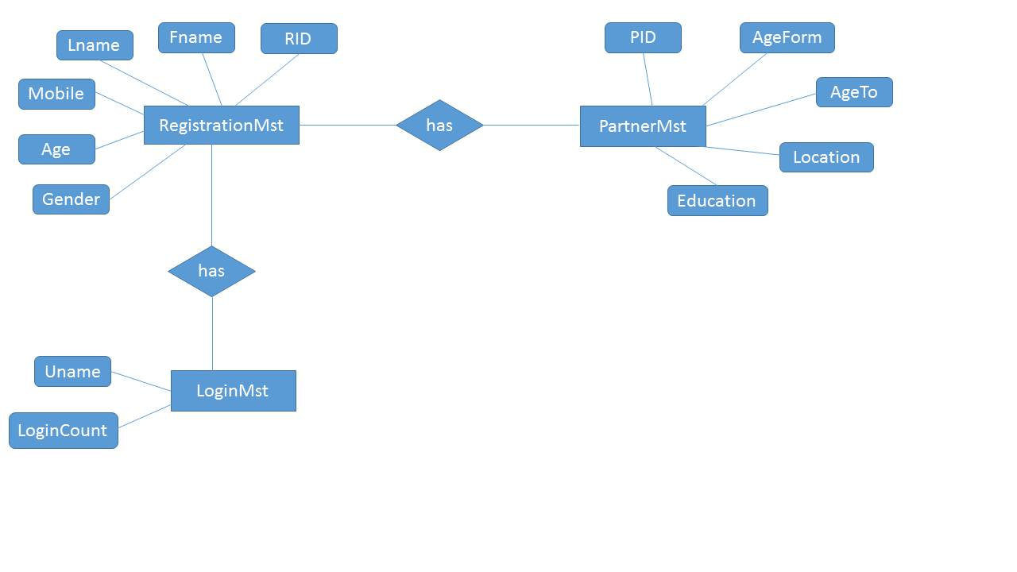

DFD’S

1.

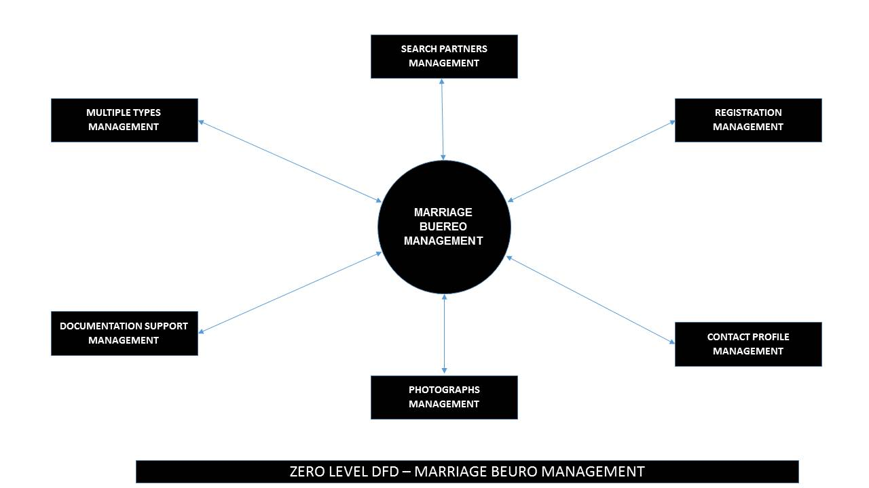

2.



3.

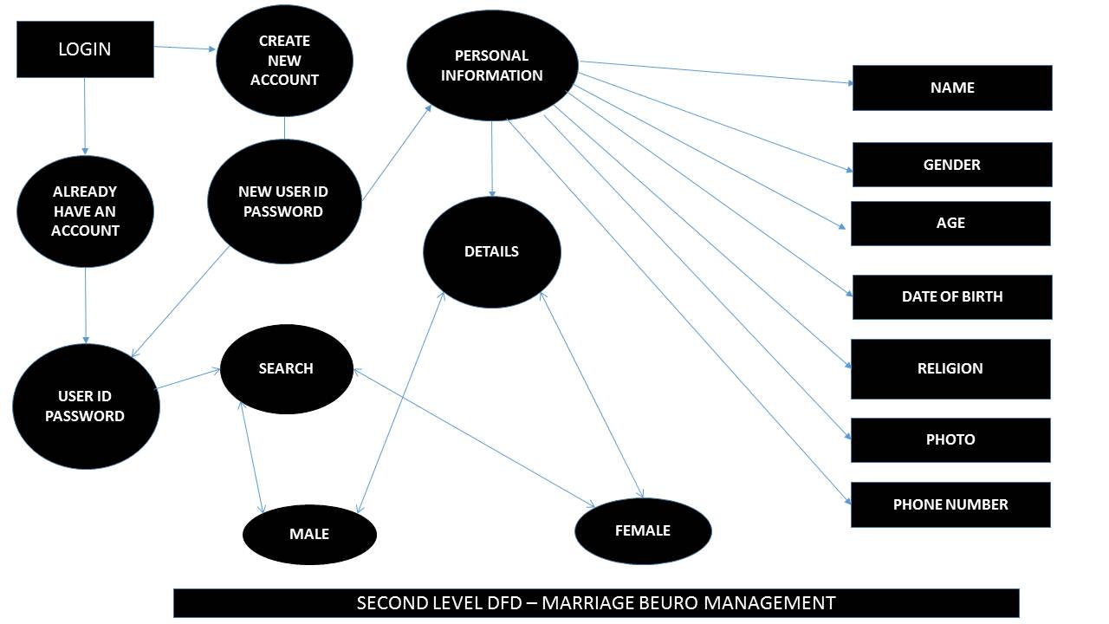

Food

**SYSTEM TESTING**

Testing is a process of executing a program with the interest of finding an error. A good test is one that has high probability of finding the yet undiscovered error. Testing should systematically uncover different classes of errors in a minimum amount of time with a minimum amount of efforts. Two classes of inputs are provided to test the process

* A software configuration that includes a software requirement specification, a design specification and source code.
* A software configuration that includes a test plan and procedure, any testing tool and test cases and their expected results.

Testing is divided into several distinct operations:

* **Unit Testing**

Unit test comprises of a set tests performed by an individual program prior to the integration of the unit into large system. A program unit is usually the smallest free functioning part of the whole system. Module unit testing should be as exhaustive as possible to ensure that each representation handled by each module has been tested. All the units that makeup the system must be tested independently to ensure that they work as required.

During unit testing some errors were raised and all of them were rectified and handled well. The result was quiet satisfactory and it worked well.

* **Integration Testing**

Integration testing is a system technique for constructing the program structure while at the same time conducting tests to uncover errors associated with interfacing. The objective is to

take unit tested modules and build a program structure that has been dictated by design. Bottom-up integration is the traditional strategy used to integrate the components of a software system into functioning whole. Bottom-up integration consists of unit test followed by testing of the entire system. A sub-system consists of several modules that communicated with other defined interface.

The system was done the integration testing. All the modules were tested for their compatibility with other modules .They test was almost successful. All the modules coexisted very well, with almost no bugs. All the modules were encapsulated very well so as to not hamper the execution of other modules.

* **Validation Testing**

After validation testing, software is completely assembled as a package, interfacing errors that have been uncovered and corrected and the final series of software test; the validation test begins. Steps taken during software design and testing can greatly improve the probability of successful integration in the larger system. System testing is actually a series of different tests whose primary purpose is to fully exercise the compute –based system.

* **Recovery Testing**

It is a system that forces the software to fail in a variety of ways and verifies that the recovery is properly performed.

* **Security Testing**

It attempts to verify that protection mechanisms built into a system will in fact protect it from improper penetration. The systems security must of course be tested from in vulnerability form frontal attack.

* **Stress Testing**

Stress tools are designed to confront programs with abnormal situations. Stress testing executes a system in a manner that demands resources in abnormal quantity and volume.

* **Black Box Testing**

Black box testing is done to find out the following information as shown in below:

* Incorrect or missing functions.
* Interface errors.
* Errors or database access.
* Performance error.
* Termination error.

The mentioned testing is carried out successfully for this application according to the users requirement specification.

* **Test Data Output**

After preparing test data, the system under study is tested using the test data. While testing the system using test data, errors are again uncovered and corrected by using above testing and corrections are also noted for future use

1. SYSTEM FORMS

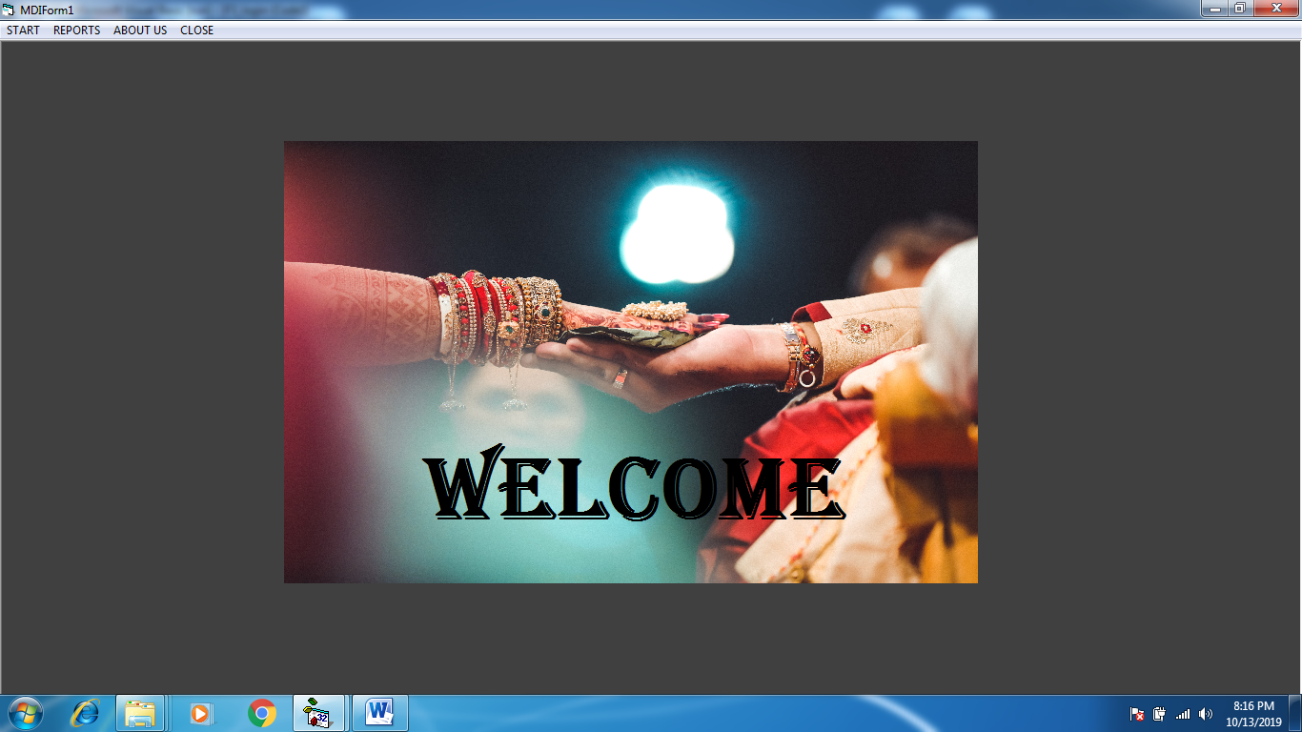1.MDI FORM [WELCOME SCEEN]:-

2. FORM 1 START:-

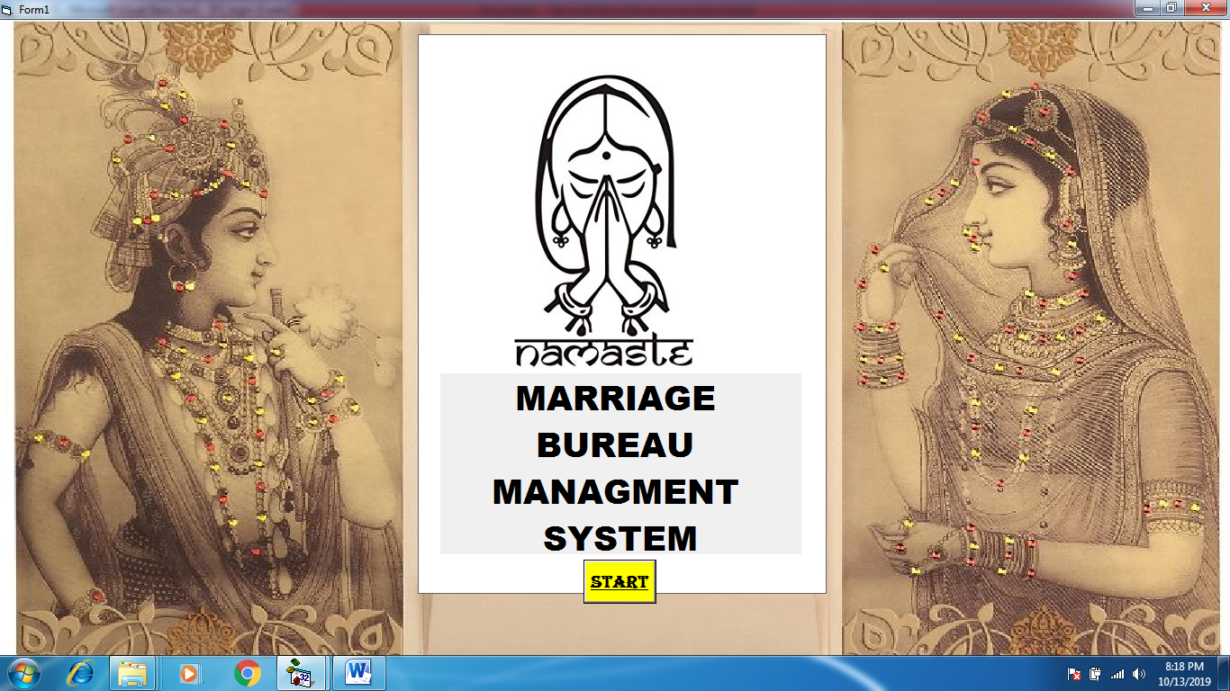

2.1 PROGRESSBAR:-

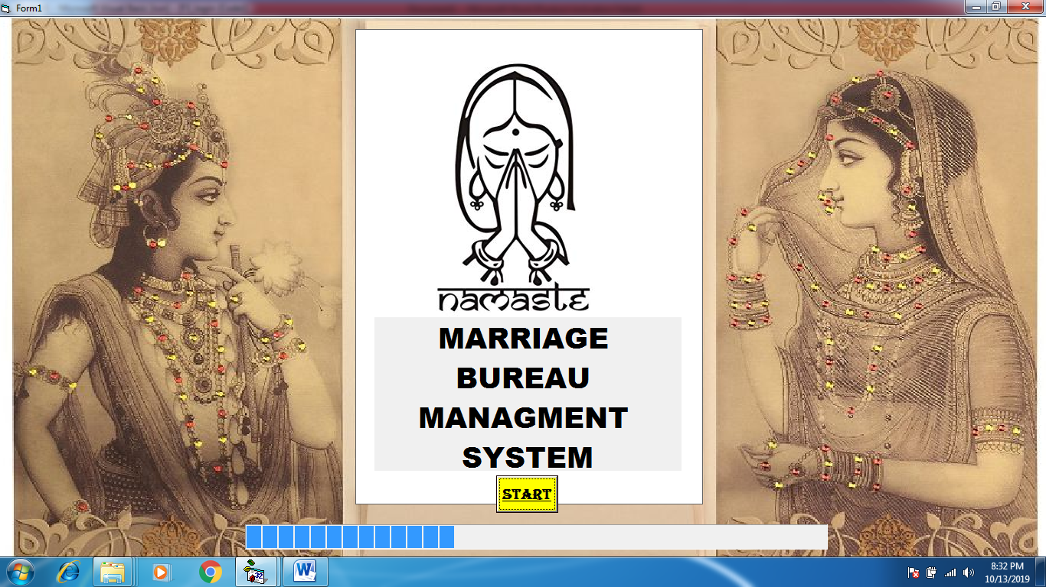

2.2 MESSAGE BOX:-

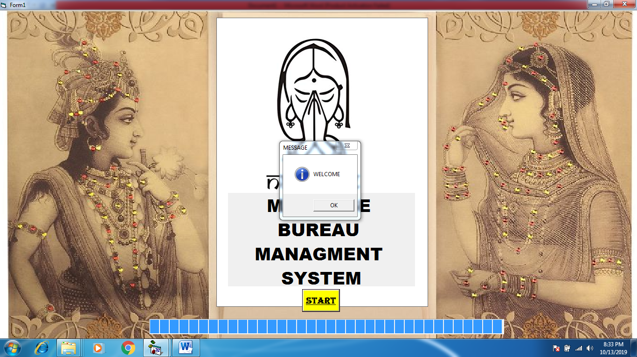

3. FORM 2 DESCRIPTIONS

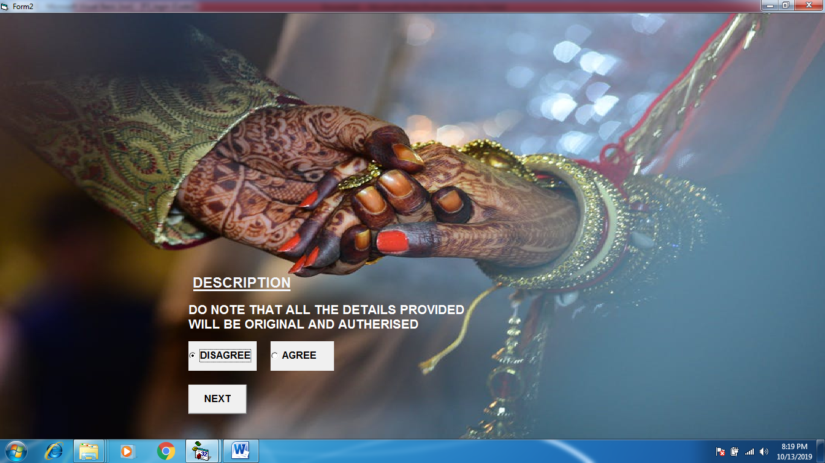

3.1 OPTION “AGREE” WHEN SELECTED:-

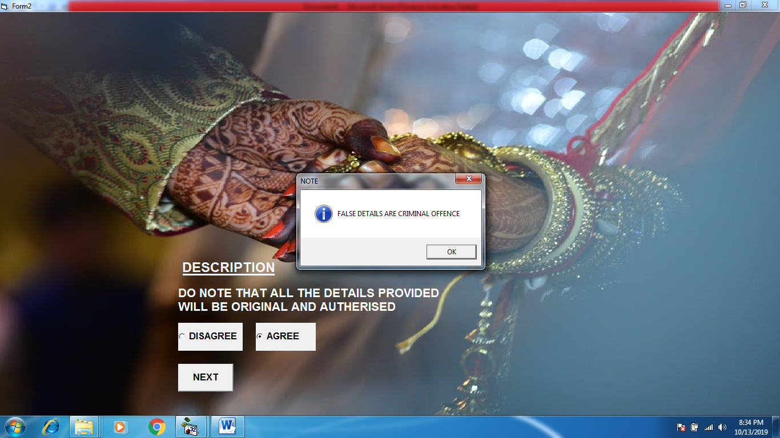

4. FORM 3 LOGIN

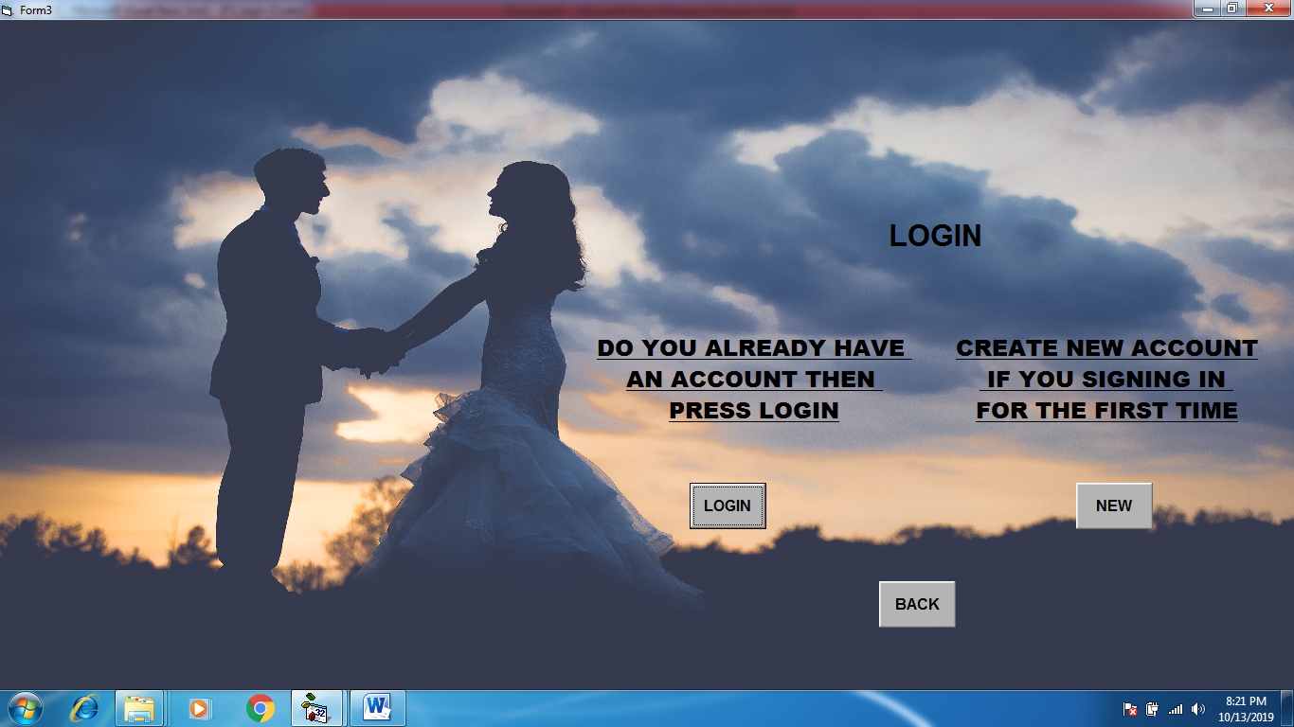

5. FORM 4 ALREADY ACCOUNT:-

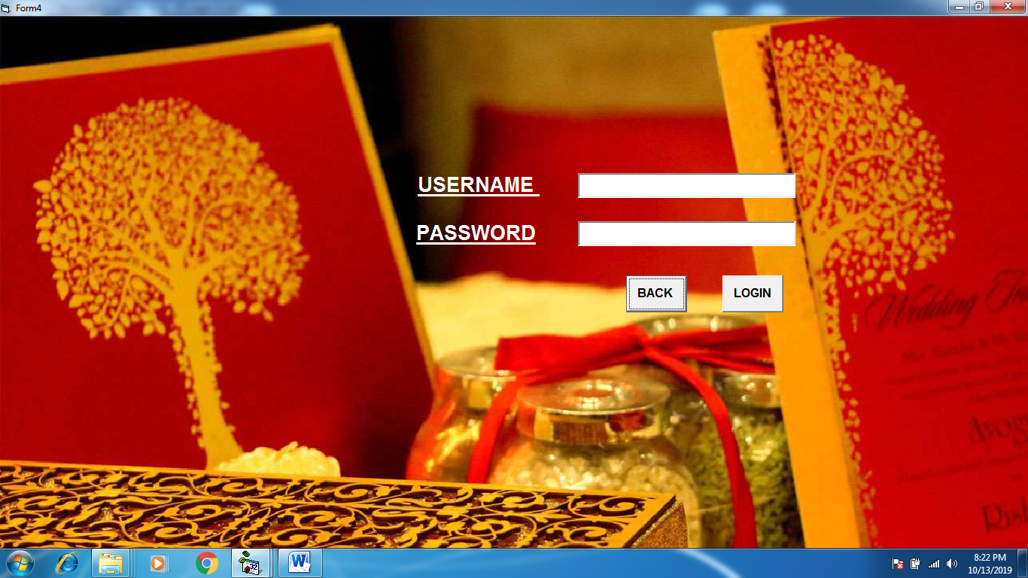

5.1 WHEN INCORRECT PASSWORD :-

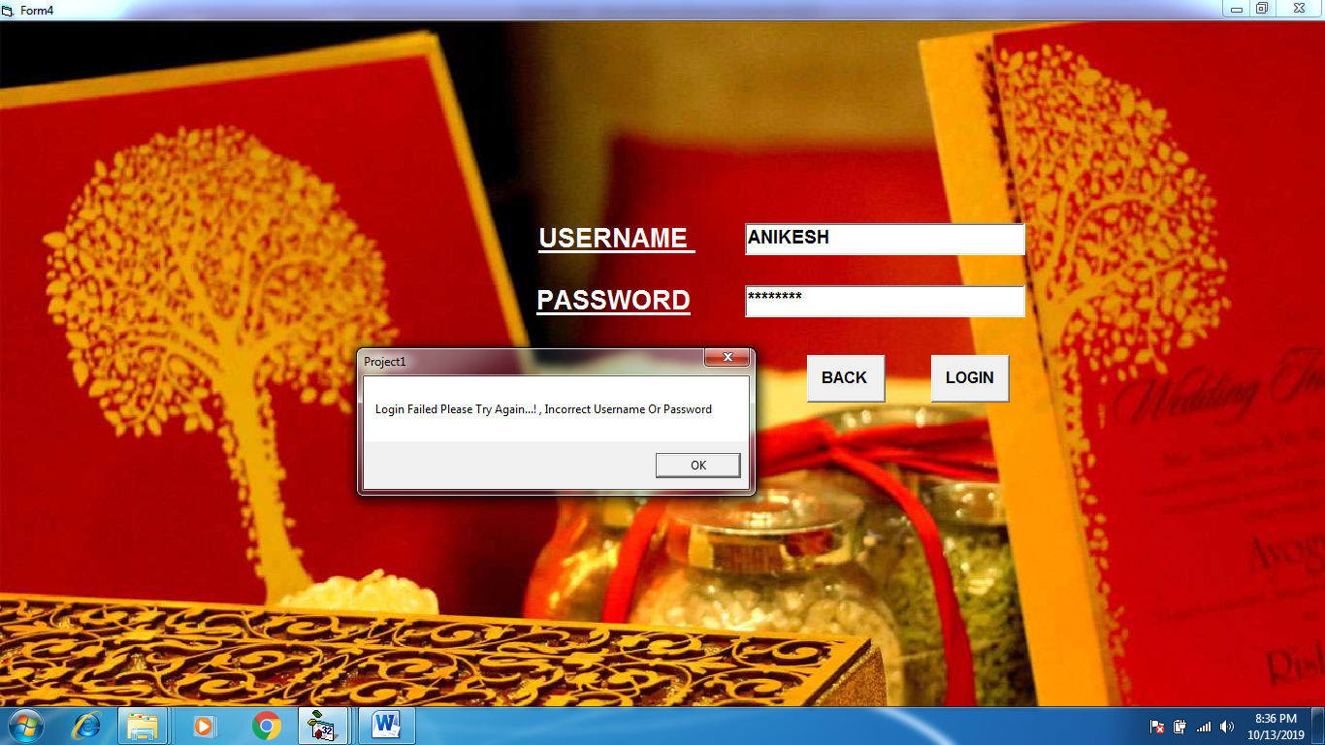

6. FORM 5 CREATES NEW ACCOUNT:-

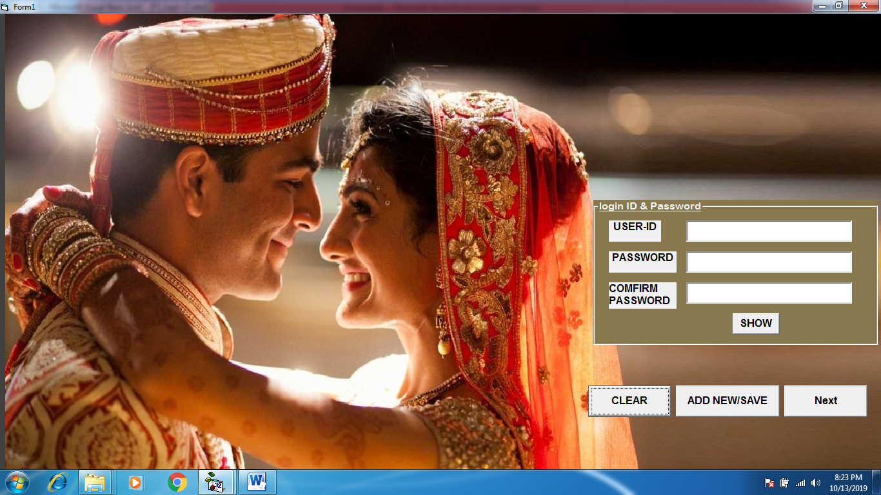

6.1 WHEN PASSWORD AND COFIRM PASSWORD DOESN’T MATCHES:-

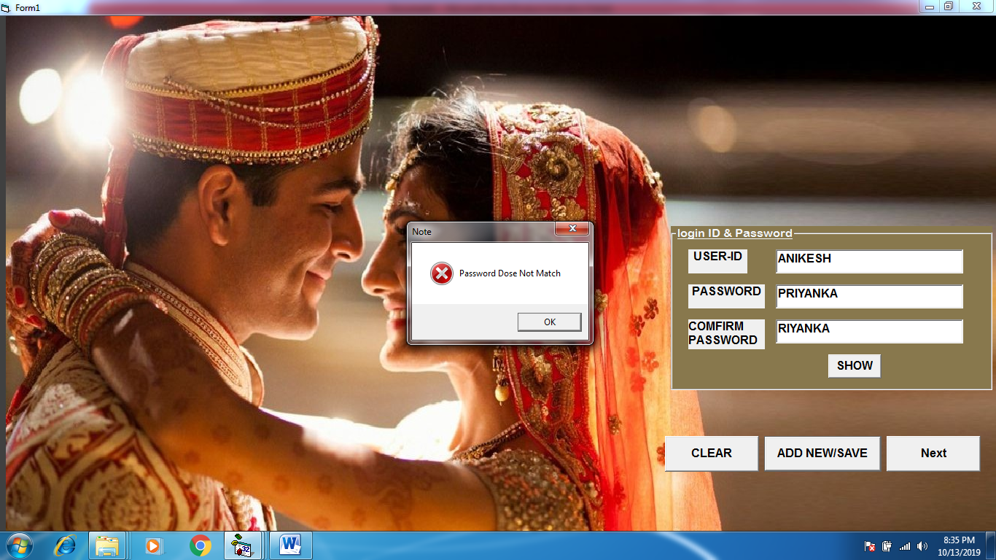

6.2 WHEN ID AND PASSWORD IS CORRECT:-

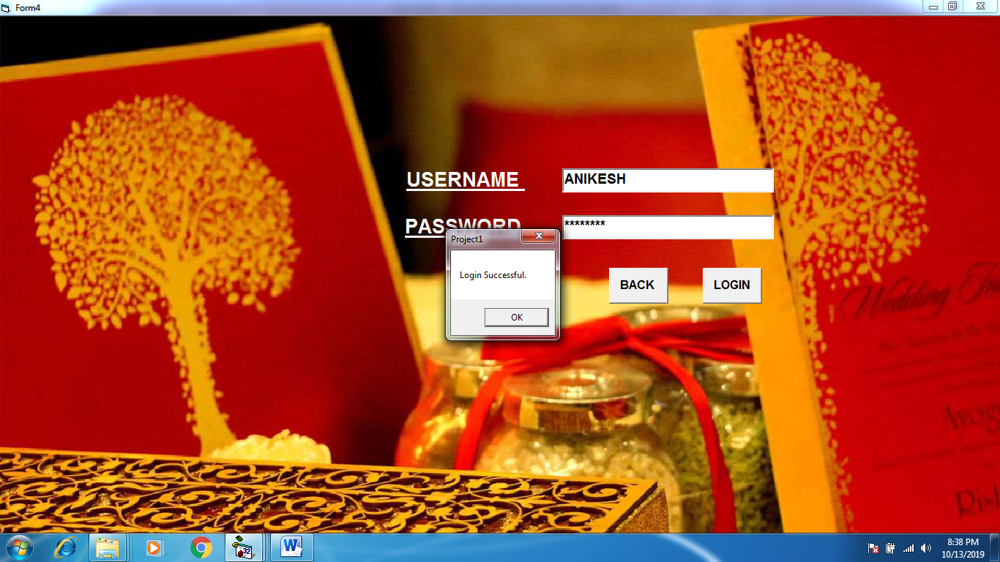

7. FORM 6 PERSONAL INFORMATION:-

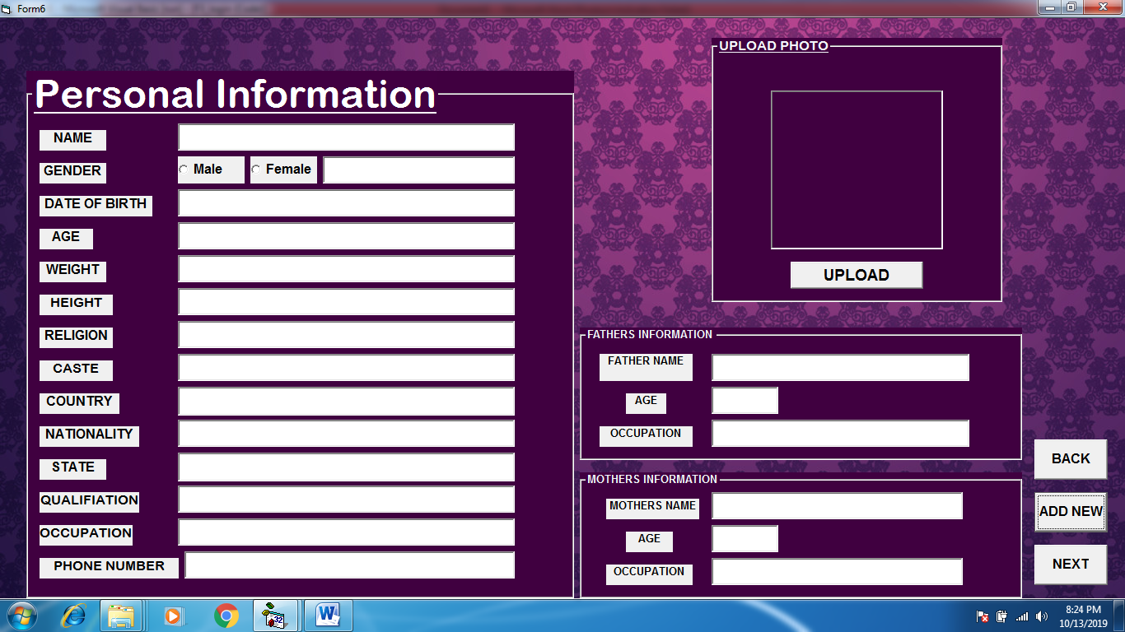

8. FORM 7 DETAILS:-

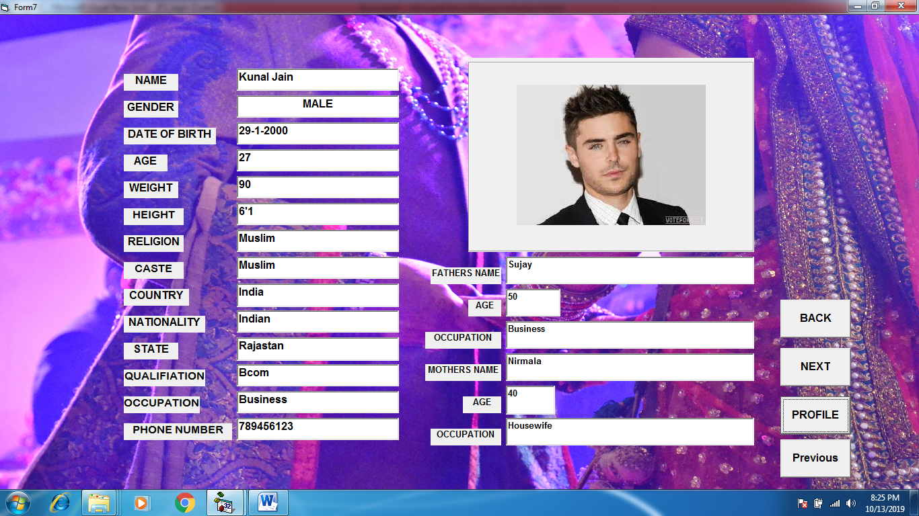

9. FORM 8 SEARCH:-

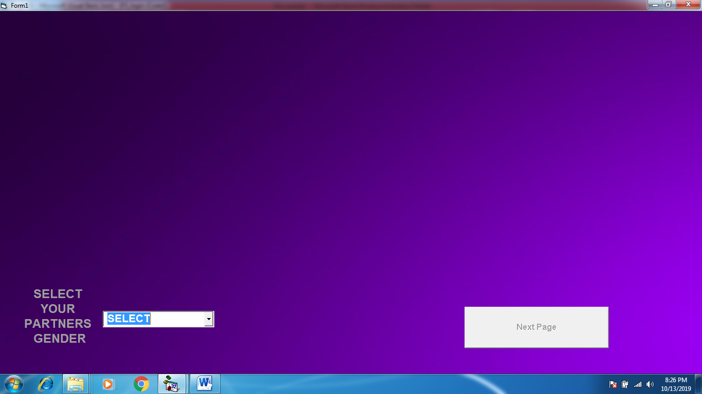

9.1 IF OPTION MALE SELECTED:-

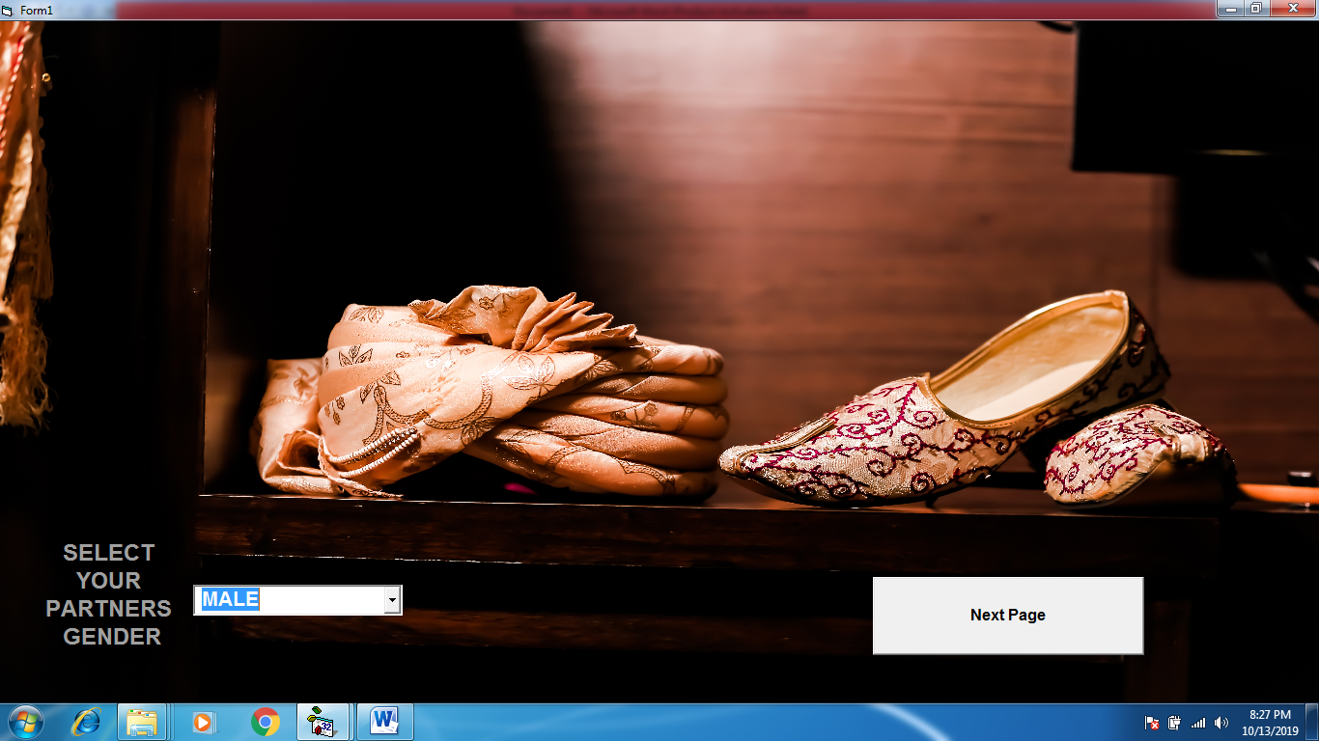

9.2 IF OPTION FEMALE SELECTED:-

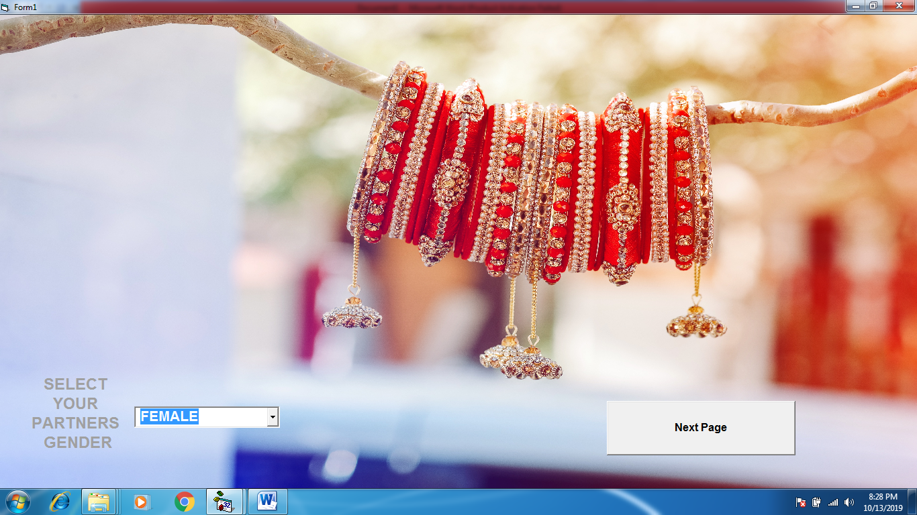

10.RESULTS FORM:-

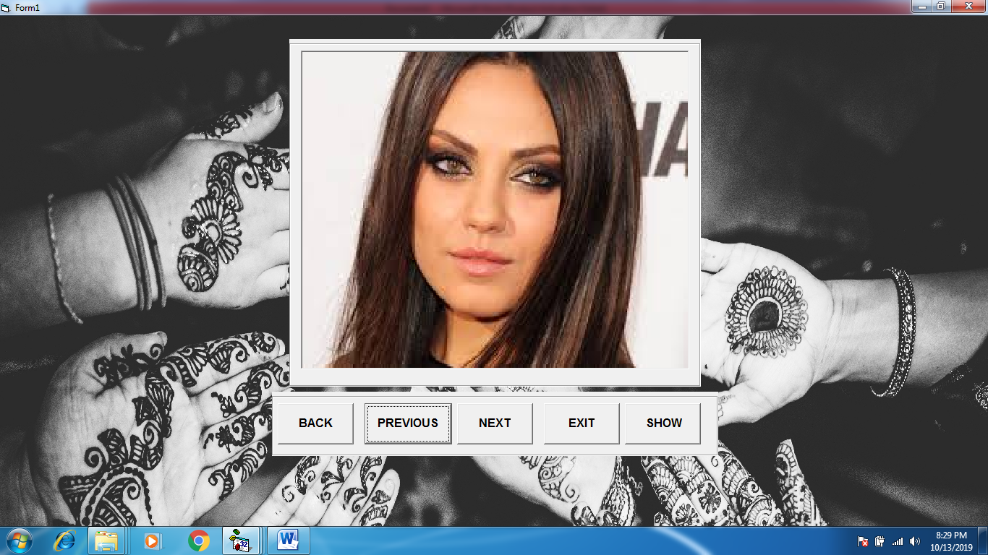

10.1 FOR MALE DATA :-

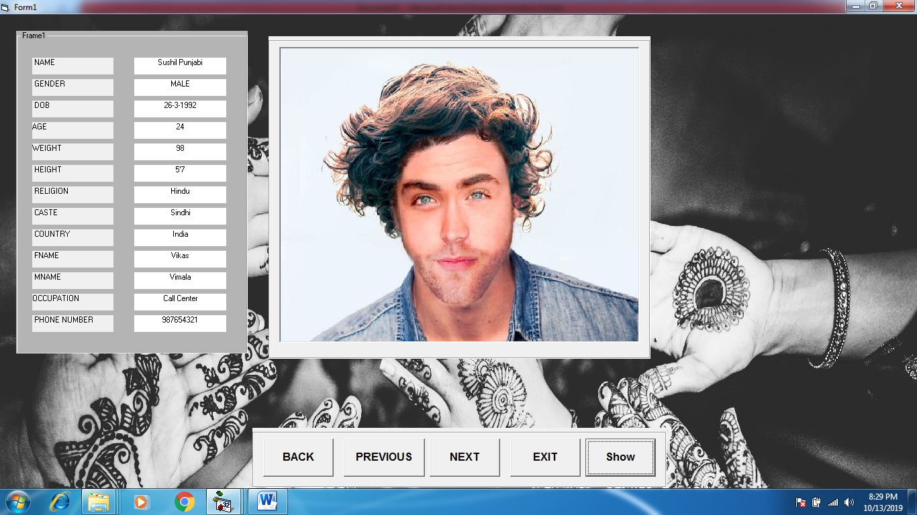

10.2 FOR FEMALE DATA:-

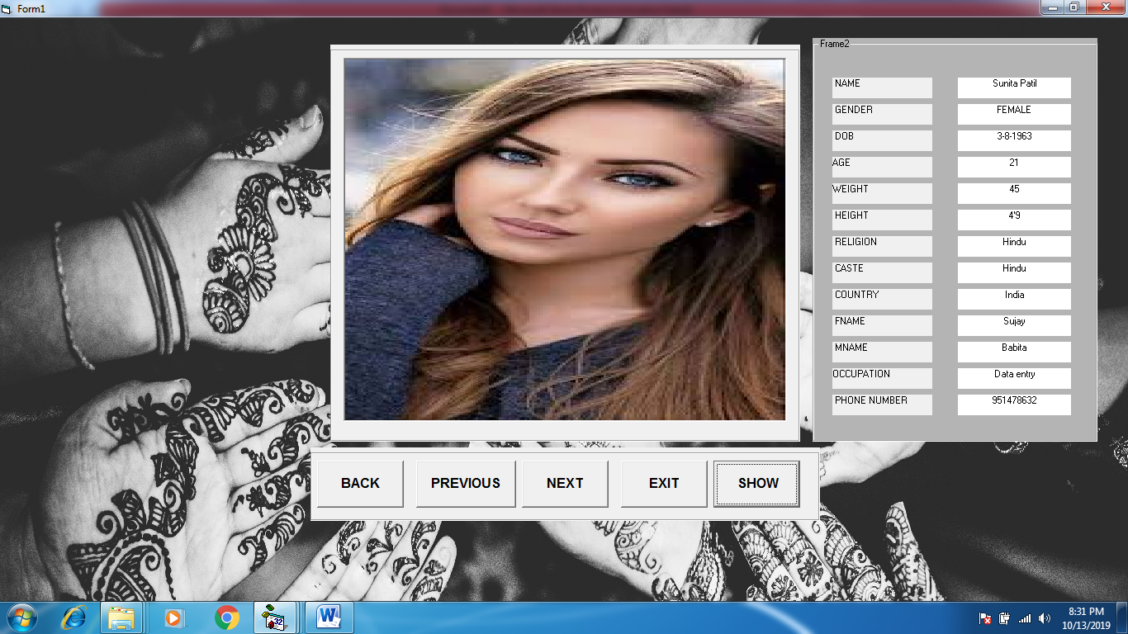

11. FORM THANK YOU:-

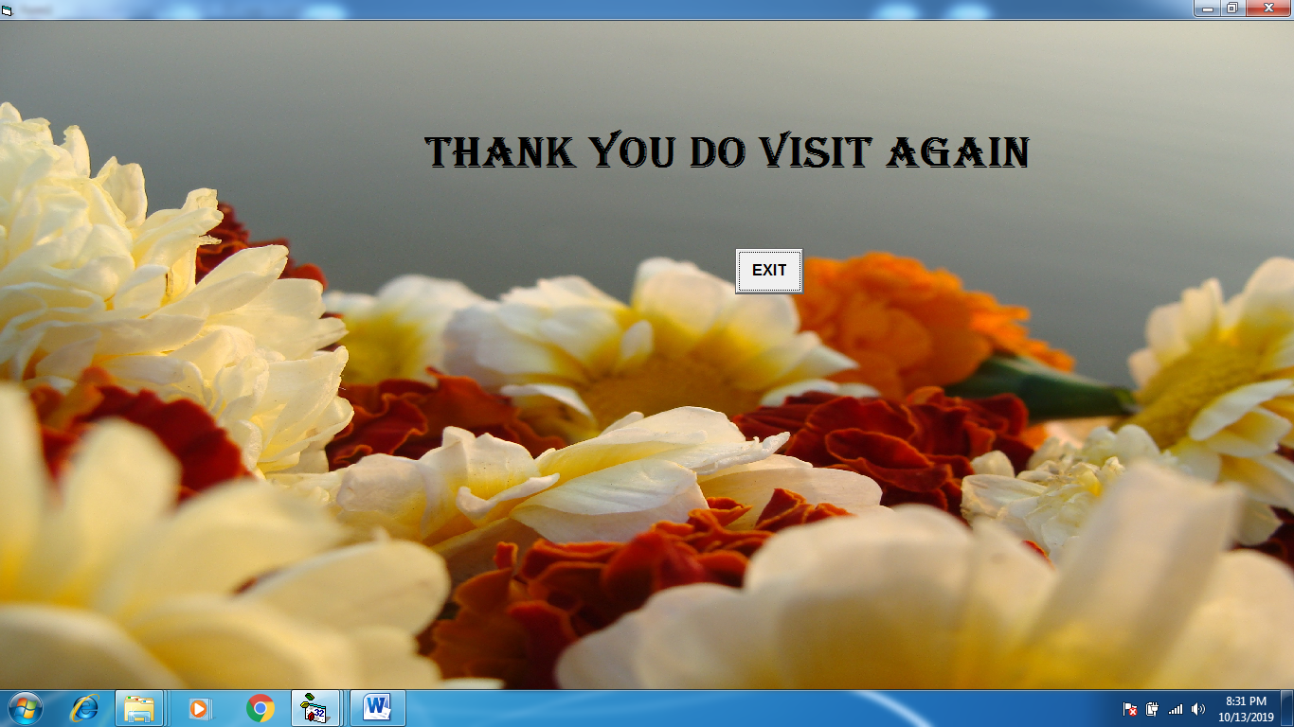

12. MDI MENU – ABOUT US:-

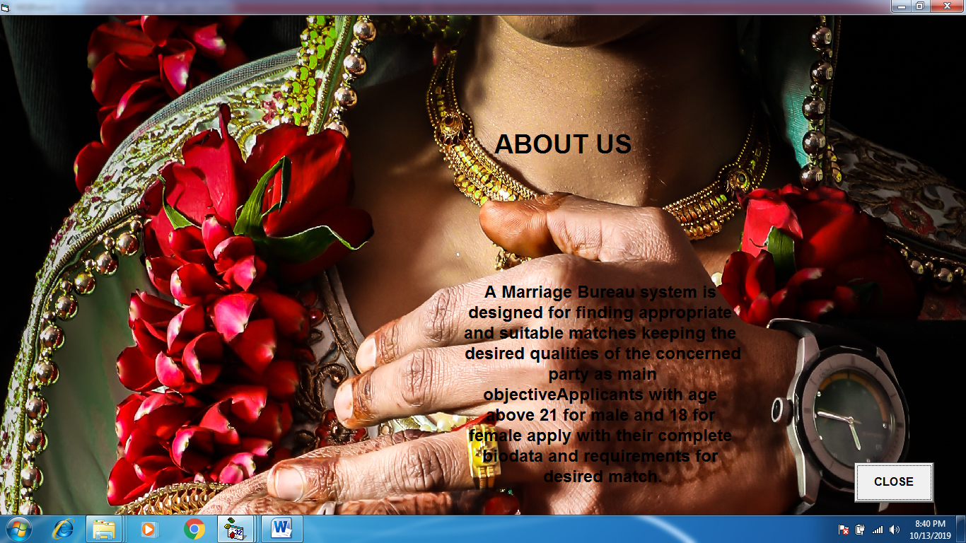

**Report’s :-**

**ALL CANDIDATES REPORTS:-**

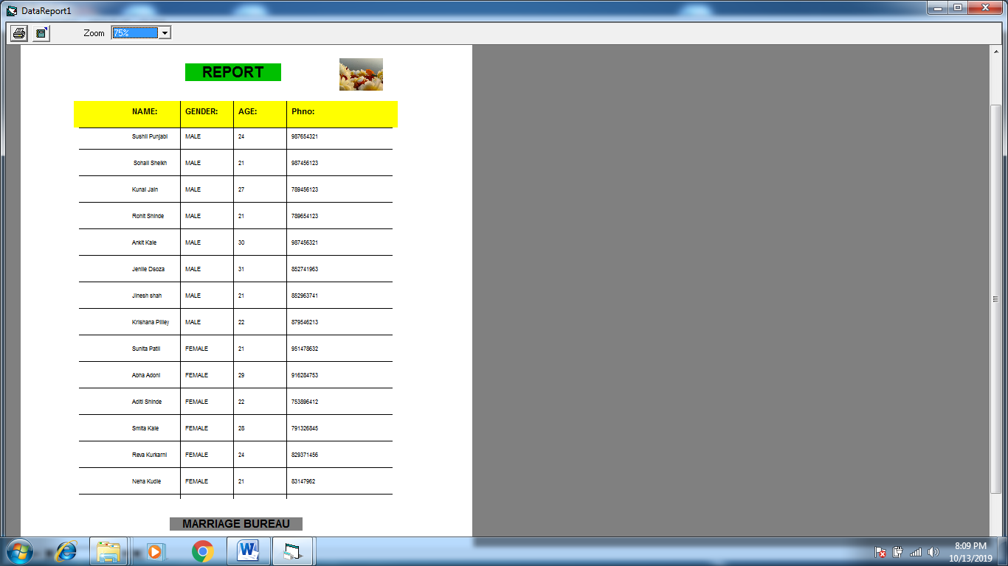

1. Data Dictionary

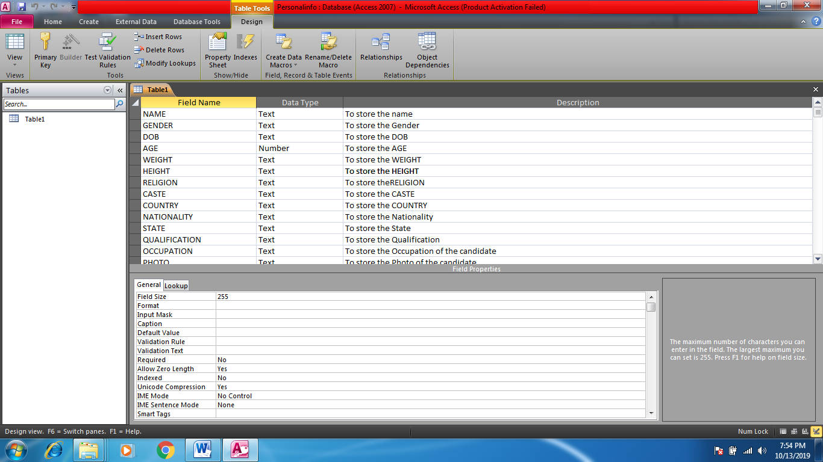**PERSONALINFO :-**

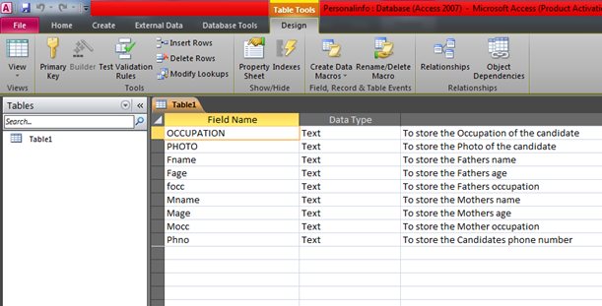

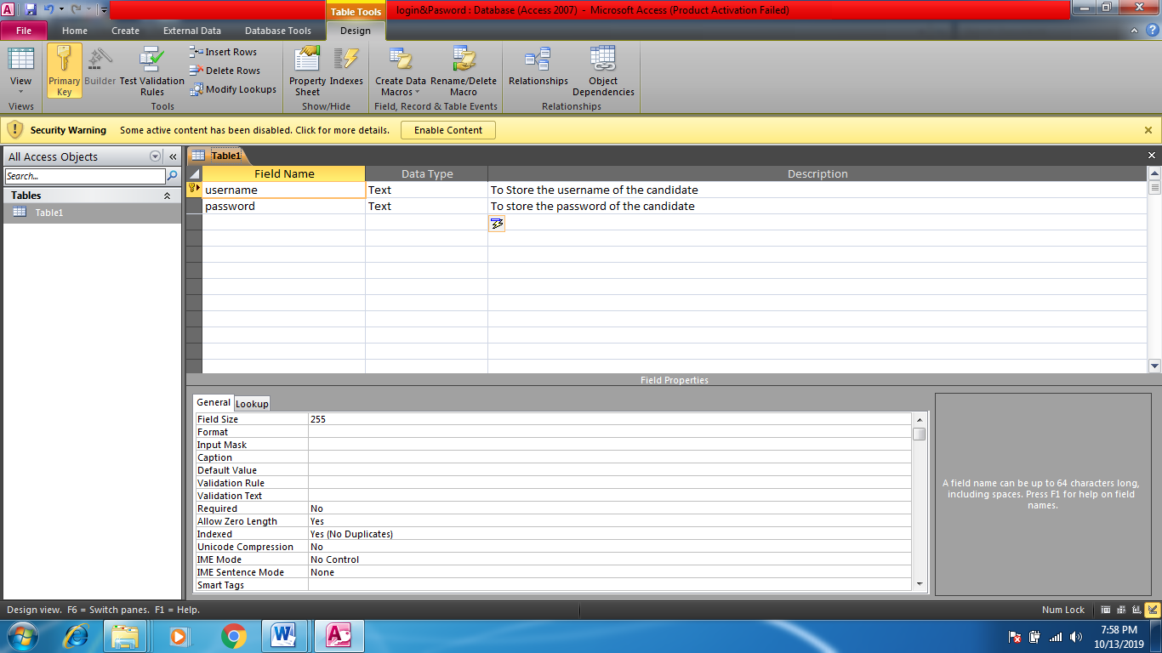**LOGIN & PASSWORD:-**

1. FUTURE ENHANCEMENTS

* We Can Update the fields at the time of seeing the details
* Search category will have more fields as Age ,Religion etc for searching a right partner
* Connection over the internet
* Communication will be possible because of internet
* If the candidate in future gets married can delete his or her account
* There will to be increase in the scope of the software as in state and countries
* The Best Security Also We Can Provide In Next Update

1. SOFTWERE REQUIRMENTS

Operating System -:

Windows 2000, VISTA

Windows XP (Any Service Pack)

Windows 7, 8, 8.1, 10 (both 32-bit & 62-bit)

Office -:

Microsoft Office 2007 & above

Programming Language -:

Microsoft Visual Basic 6.0 (frontend)

Microsoft Access Database 2007 (backend)

Type of Connection -:

ADODC

1. HARDWERE REQUIRMENTS

Processor -:

Intel Pentium-III or above, 600 MHz

RAM -:

Minimum 256 Mb RAM Required For System

Hard Disk -:

Total Disk Size Minimum 60 GB or More

Free Space 900 Mb or More

Screen Resolution -:

800 x 600, 256 Colour Resolution Minimum

CD-Drive / USB Drive -:

If User Is Using CD or USB Installation

1. BIBLIOGRAPHY

BOOKS

* A Complete Guide to Programming in Visual Basic 6.0
* A Complete Visual Basic 6 Training Course: How to Programmed Package
* Advanced Programming Using Visual Basic: Version 6.0
* Access 2003 Power Programming with VBA
* Advanced MS Visual Basic

ONLINE HELP

* Sandeep Kulkarni YouTube Chanel
* Ramdas Biradar Wbsite
* www.1000projects.com